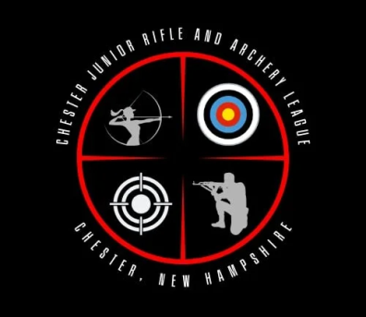

To: All Chester Junior Rifle and Archery League

Age Group: Those 17 and up that are interested in Concealed Carry Informational Class

We are excited to offer our older 4-H members a chance to train with one of the most skilled instructors at Chester Rod and Gun Club, Kevin Laliberte. Kevin would like to host an informational meeting with the hope of conducting a class on the responsibilities, logistics, and skill sets necessary for concealed carry.

This meeting is open to any of our older 4-H members who are 17 years old or older and will help Kevin to mold the class to best suit his audience, If this is something that is of interest to you please let us know so that we can set up a day and time. There is no charge for this meeting.

If you have any further questions please see Chris Fazzio, Instructor and Volunteer Leadership. Reply to this email with subject line: Concealed Carry to contact Chris Fazzio for Q n A.

If you have a youth interested in this class please sign up. We will set up a date and time once the class has enough signed up.

https://signup.com/go/LLZUqrc

*** Dale Carney President
** Abigail HDS Bellemore
CJRAL Admin Secretary
4H Shooting Sports Instructor
4H Volunteer Leadership
chesterNHJRAL.org
chesterJRAL@outlook.com
abell.4vol@yahoo.com
603-235-5643

