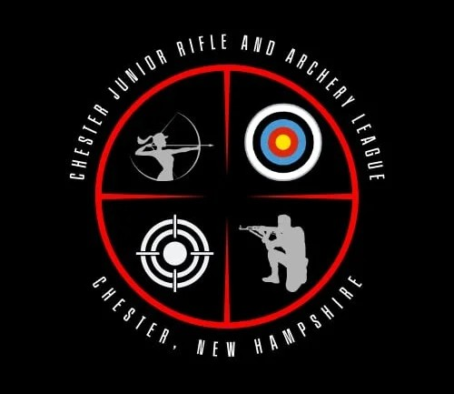

Sponsorship for Camp Barry: __________________________________________

Date:______________________________________________________________

We, the Chester Junior Rifle and Archery League, thank you for your Sponsorship $__________________.

Paid by: CASH _________ CHECK #_________ Stripe ________

Such support allows us to continue to provide quality and safe Archery and firearms activities to the youth enrolled in our programs.

With a grateful thanks,

From All the CJRAL members

Chester Junior Rifle and Archery League
99 Rod and Gun Club Rd
Chester NH 03036
Email: chesterJRAL@outlook.com
Website: chesterNHJRAL.org

** The Chester Junior Rifle and Archery League, Inc. Is a New Hampshire recognized Charitable Program in good standing (NH Business ID 926887) and is an IRS recognized 501c3 charitable organization (IRS EIN 92-3047888). All donations may be considered charitable donations if you so choose.

Sponsorship Info.

Those that sponsor a youth for Camp Barry are welcome to share their information so the youth may write a thank you card while at Camp.

Name: _____________________________________________________________

Address:____________________________________________________________

___________________________________________________________________

Email: _____________________________________________________________

Once we have a name or names of youth that benefit from your sponsorship with we CJRAL would like to share them with you also.

Thank you for sponsoring the youth of tomorrows leaders.

All of us at CJRAL

